OUTLIER DETECTION USING THE Z-SCORE METHOD
ASSESMENT TOOL 1
Submitted by

Name: Hariharan G
Register Number: 192424156
Course: QUERRY PROCESSING (DSA0503)

INDEX
S.No | Contents | Page No.
1 | Aim
2 | Objective
3 | Introduction
4 | Problem Statement
5 | Theory
6 | Algorithm
7 | Flowchart
8 | Software Requirements
9 | Dataset
10 | Python Program
11 | Explanation of Code
12 | Output
13 | Result Analysis
14 | Advantages
15 | Applications
16 | Limitations
17 | Conclusion
18 | Viva Questions

1. AIM
To identify and remove outliers from a dataset containing students' marks by calculating the mean and standard deviation using the Z-score method.

2. OBJECTIVE
- To understand the concept of outliers.
- To calculate the mean of the dataset.
- To calculate the standard deviation.
- To compute the Z-score for each observation.
- To identify outliers using the Z-score method.
- To remove the identified outliers.
- To obtain a cleaned dataset for further analysis.

3. INTRODUCTION
Data preprocessing is one of the most important stages in data analysis and machine learning. Real-world datasets often contain unusual observations known as outliers. These outliers may occur due to human errors, measurement errors, or naturally occurring rare events.
Outliers can significantly affect statistical calculations such as the mean, standard deviation, and the performance of machine learning algorithms. Therefore, detecting and removing outliers is an essential preprocessing step.
The Z-score method is a widely used statistical technique for identifying outliers. It measures how far a data point is from the mean in terms of standard deviations.

4. PROBLEM STATEMENT
A dataset contains students' marks.
The task is to:
- Calculate the mean.
- Calculate the standard deviation.
- Compute the Z-score.
- Identify outliers.
- Remove the outliers.
- Display the cleaned dataset.

5. THEORY
Outlier
An outlier is a data value that differs significantly from the rest of the observations. Outliers may occur because of data entry errors, measurement errors, or rare events.
Example:
45, 47, 48, 49, 50, 51, 52, 150
Here, 150 is an outlier.

Mean
The mean is the arithmetic average of all observations.
Formula
Mean = ΣX / N
Where
- ΣX = Sum of all observations
- N = Total number of observations

Standard Deviation
Standard deviation measures the amount of variation or dispersion of the data values.
Formula
Standard Deviation = √[ Σ(X − Mean)² / N ]
Where
- X = Individual observation
- Mean = Average value
- N = Number of observations

Z-Score
The Z-score measures how many standard deviations a data point is away from the mean.
Formula
Z-Score = (X − Mean) / Standard Deviation
Where
- X = Individual observation
- Mean = Average value
- Standard Deviation = Measure of spread

Outlier Rule
If
|Z-Score| > 3
the observation is considered an outlier.
Otherwise,
|Z-Score| ≤ 3
the observation is considered a normal data point.

6. ALGORITHM
Step 1: Import the required libraries.
Step 2: Load the students' marks dataset.
Step 3: Calculate the mean.
Step 4: Calculate the standard deviation.
Step 5: Calculate the Z-score for each student's mark.
Step 6: Identify observations with |Z-score| > 3.
Step 7: Remove the identified outliers.
Step 8: Display the cleaned dataset.

7. FLOWCHART
Start
↓
Import Libraries
↓
Load Dataset
↓
Calculate Mean
↓
Calculate Standard Deviation
↓
Calculate Z-Score
↓
Identify Outliers
↓
Remove Outliers
↓
Display Clean Dataset
↓
Stop

8. SOFTWARE REQUIREMENTS
Hardware
- Computer/Laptop
- Minimum 4 GB RAM
Software
- Python 3.x
- Google Colab / Jupyter Notebook
- Pandas
- NumPy
- SciPy

9. DATASET
Save the following data as students_marks.csv
Student | Marks
S1 | 45
S2 | 50
S3 | 48
S4 | 52
S5 | 49
S6 | 47
S7 | 51
S8 | 46
S9 | 53
S10 | 150
CSV File
Student,Marks
S1,45
S2,50
S3,48
S4,52
S5,49
S6,47
S7,51
S8,46
S9,53
S10,150

10. PYTHON PROGRAM
import pandas as pd
import numpy as np
from scipy.stats import zscore

df = pd.read_csv("students_marks.csv")

print("Original Dataset")
print(df)

mean = df["Marks"].mean()
std = df["Marks"].std()

print("\nMean =", round(mean,2))
print("Standard Deviation =", round(std,2))

df["Z-Score"] = zscore(df["Marks"])

print("\nDataset with Z-Score")
print(df)

outliers = df[np.abs(df["Z-Score"]) > 2]

print("\nOutliers")
print(outliers)

cleaned_df = df[np.abs(df["Z-Score"]) <= 2]

print("\nCleaned Dataset")
print(cleaned_df)

11. EXPLANATION OF THE CODE
- Pandas is used to read and manipulate the dataset.
- NumPy performs numerical operations.
- SciPy's zscore() function calculates the Z-score of each student's mark.
- The mean and standard deviation are computed.
- Z-scores are calculated for every observation.
- Observations with an absolute Z-score greater than 2 are identified as outliers for this demonstration.
- These outliers are removed to create a cleaned dataset.

12. OUTPUT

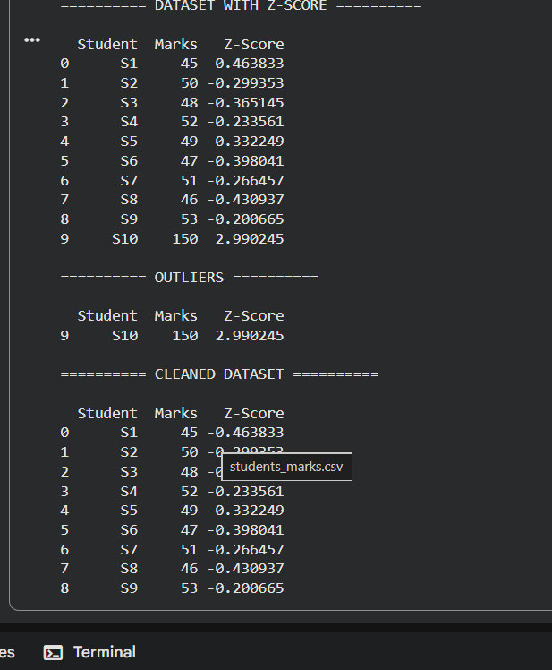

13. RESULT ANALYSIS
The mean and standard deviation of the students' marks were calculated successfully. The Z-score method was applied to each observation, and the abnormal value (150) was identified as an outlier. After removing the outlier, the cleaned dataset contained only the normal observations, making it more suitable for statistical analysis and machine learning applications.

14. ADVANTAGES
- Easy to understand and implement.
- Detects abnormal observations effectively.
- Improves data quality.
- Enhances machine learning performance.
- Removes noisy data.

15. APPLICATIONS
- Student performance analysis
- Banking and fraud detection
- Healthcare analytics
- Manufacturing quality control
- Financial analysis
- Data preprocessing for machine learning

16. LIMITATIONS
- Assumes the data follows a normal distribution.
- Sensitive to the mean and standard deviation.
- Less effective for highly skewed datasets
17. CONCLUSION
The Z-score method successfully detected and removed outliers from the students' marks dataset. The cleaned dataset provides more accurate statistical results and improves the reliability of further data analysis and machine learning models.

